

**STATE UNIVERSITY OF ZANZIBAR(SUZA)**

**DEPARMENT OF INFORMATION TECHNOLOGY AND COMPUTER SCIENCE**

**FINAL YEAR PROJECT PROGRESS REPORT**

**BY :**

ABDILLAH UWESSU ABUBAKAR BCS/11/16/270/TZ

&

ABDUL-RAHMAN MOHAMMED HAFIDH BITAM/4/16/173/TZ

A final year project progress report submitted to the department of IT & Computer Science in partial fulfillment of the requirement for the award of the bachelor of IT Application & Management & Bachelor of Science in Computer Science

**9th January , 2019.**

# DECLARATION

I sincerely declare that this report is prepared by our own struggle as well effort and all the content in report are from what tasks we did for the Open Digital Zanzibar project

Prepared by Prepared by

…...................................... …………………………….

Abdul-rahman M.Hafidh Abdilllah Uwessu Abubakar

Supervised by

………………

Mr. Ali Abdulla Ali

# ABSTRACT

ZMI data hasn’t been utilized accordingly in Zanzibar. Commission of Land (COLA) has just started digitizing the buildings in the city main aim for municipal and revenue tasks. But still they can be used for different other use cases like show the infrastructures to be built after certain of time.

And also, there are many challenges like unplanned residences.

Our solution will involve a mobile app which will include latest map of Zanzibar and Zanzibar master plan (The Big Zanzibar Project). So, the citizens can know and feel part of the project.

Our main objective is to create a platform which all stakeholders can access. So, they can be aware of the infrastructures and assets found and what are the future plans of the country regarding land use.

The project is feasible in all aspects except legally. But talks have been made already for looking for the best alternative solutions.

Object oriented approach will be used. Software tool to be used will range from mapping to scripting. And the main SDLC model which will be used is waterfall but sometimes even rapid prototyping.

A presentation was done where a discussion followed later to know the point of views and the inputs of the clients.

Contents

DECLARATION ii

ABSTRACT 3

LIST OF FIGURES 5

**ABREVIATIONS** 6

**1. CHAPTER ONE : Introduction** 7

**1.1 Background** 7

**1.2 Problem statement** 7

**1.3. Problems Solution and the scope** 7

**1.4. Objectives.** 7

**1.5. Literature review** 7

**1.6. Feasibility study.** 7

**2. CHAPTER TWO: Methodology** 9

**2.1 Software Development approach** 9

**2.2 Software Development Life Cycle (SDLC)** 9

**2.4 System Architecture** 9

**2.4 Software development tools** 10

**3. CHAPTER 3: Requirement Analysis & Gathering** 11

**3.1 Requirement determination** 11

**3.1.1 Information gathering techniques** 11

**3.1.2 Functional requirement** 11

**3.1.3 Non – functional requirement** 11

**3.2 Requirement Structuring** 11

**3.2.1 Process Model** 12

**3.2.2 Data Modeling** 13

**4 CHAPTER 4: System Design** 15

4.1 Architectural Design 15

4.2 Database Design 16

4.2.1 Relational Model 16

4.2.2 Data Description 16

4.2.3 Data Dictionaries 17

4.3 User Interface Design 19

4.3.1 Forms and reports 19

4.3.2 Interface design sample 20

**REFERENCES** 23

Mathers ,Smather (2017, June 12) ZMI - Zanzibar Mapping Initiative Level 1 . Retrieved from 23

# LIST OF FIGURES

Figure 1: System architecture 9

Figure 2 : Current System Use Case Diagram 12

Figure 3 : Proposed System Use Case Diagram 12

Figure 4: Class Diagram 13

Figure 5 : Entity Relationship Diagram (ERD) 14

# **ABREVIATIONS**

ERD: Entity Relationship Diagram

OSM: Open Street Map

QGIS: Quantum Geographical Information System

ZMI : Zanzibar Mapping Initiative

# **1. CHAPTER ONE : Introduction**

## **1.1 Background**

ZMI data and OpenStreetMap data for variety of issue that will boost forward the infrastructure sector in Zanzibar. Hasn’t been utilized accordingly in Zanzibar. Commission of Land (COLA) has just started digitizing the buildings in the city main aim for municipal and revenue tasks. But still they can be used for different other use cases like show the infrastructures to be built after certain of time.

## **1.2 Problem statement**

* Currently we are suffering from unplanned residences especially in urban area and we don’t have easy way to get information in which areas we are eligible to build, doing agriculture activities or which is the boundaries of military camps.
* Also, we don’t have specific platform to show us the master plan of Zanzibar. And accessing this information has been challenging.

## **1.3. Problems Solution and the scope**

A mobile app which will include latest map of Zanzibar and Zanzibar master plan (The Big Zanzibar Project). So, the citizens can know and feel part of the project.

The app will have map that shows area and activities performed there. Example this area allowed to building, it will show the flood prone areas as well.

## **1.4. Objectives.**

To create a platform which all stakeholders can access. So, they can be aware of the infrastructures and assets found and what are the future plans of the country regarding land use.

**1.5. Literature review**

Zanzibar Mapping Initiative (ZMI) is the largest civilian drone mapping project in the world, an ambitious project to map the Zanzibar islands using eBee drone. The project is nearly complete. Aim to discuss it is ZMI app which have ZMI data and you can view data and download them if you need. (Mathers ,Smather )

Google map is a web mapping service developed by Google. It offers satellite imagery, streets (street View), real-time traffic conditions (Google Traffic), and route planning for traveling by foot, car, bicycle and public transportation.

OpenStreetMap (OSM) is a collaborative project to create a free editable map of the world rather than the map itself, the data generated by the project is considered its primary output. The creation and growth of OSM has been motivated by restriction on use or availability of map information across much of the world, and the advent of inexpensive portable satellite navigation devices.

**1.6. Feasibility study.**

Operational feasibility: According to much time visiting at Commission of Land (COLA) and having much discuss and check out the functionality, working mode of the application and resources they got it feasible. However main challenges come with the bureaucracy in decision making and taking action.

Economic feasibility: The resources that will be available and required for the mobile application is affordable and we glad that they have all important resources we need for the application.

Schedule feasibility: Time given to implement the project is reasonable but the main challenges come with the bureaucracy and other factors.

Legal feasibility: Legally master plan still not publicize so explanations, discussion needed from the authorities. But they have NSDS is map shows agricultural area, shows how town will be after couple of time, shows empty spaces. They have Cardastrial map to show the boundaries of the areas and Edujication is a map that shows people whose own the plots areas couple of acres area. So due to map available it somehow seventy percent feasible. However, greatness comes when we will work under the supervision of Commission for land.

Technical feasibility: The team they have plus my team kin a technical aspect we can achieve the goal of the mobile application we expect to develop.

Marketing feasibility: Through the survey that we did through google form. We observed that there are people (Citizens) who are ready to use the mobile app.

Technological: Technological resources and other resources and other rescores to utilize them are both available and in good condition.

# **2. CHAPTER TWO: Methodology**

On this chapter we will explain more about the methodologies. In which in the software development approach we will use object oriented. On the SDLC we will use Waterfell and a little bit of rapid prototyping. For the system architecture, we expect to use the 3 tier architecture. Without forgetting the tools which are MapBox, Eclipse, QGIS, OpenStreetMap , Python, PHP, JSON & Javascript.

## **2.1 Software Development approach**

We decided to use object oriented approach because the project (on the implementation) will involve a lot of code reuse. Due to that reason, object oriented is the best approach. Not only that, but also object oriented is the modern approach. And also the nature of the programming language which will be used is object oriented i.e Java.

## **2.2 Software Development Life Cycle (SDLC)**

Due to the nature of our project. We expect to use waterfall model since there are things that need to be delivered in each phase. But otherwise during the implantation phase, we may shift a little bit on rapid prototyping for the sake of inclusivity with our clients.

## **2.4 System Architecture**

Three tiers architecture is a suitable architecture for Open Digital Zanzibar. Which include presentation layer, Application layer and Data layer.

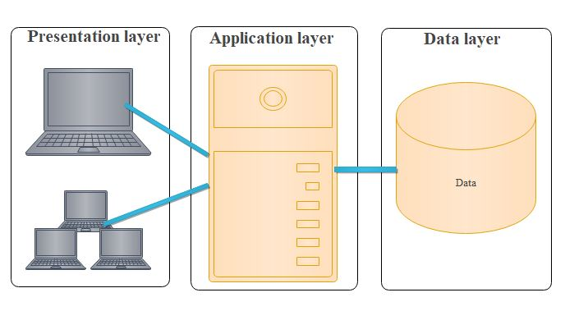

Figure 1: System architecture

**Presentation Tier**: Occupies the top level and displays information related to services available on a website or mobile application. This tier communicates with other tiers by sending results to the browser and other tiers in the network.

**Application Tier:** Also called the middle tier, logic tier, business logic or logic tier, this tier is pulled from the presentation tier. It controls application functionality by performing detailed processing.

**Data Tier:** Houses database servers where information is stored and retrieved. Data in this tier is kept independent of application servers or business logic.

With three tier architecture it gives you the following:

* It gives you the ability to update the technology stack of one tier, without impacting other areas of the application.
* It allows for different development teams to each work on their own areas of expertise. Today’s developers are more likely to have deep competency in one area, like coding the front end of an application, instead of working on the full stack.
* You are able to scale the application up and out. A separate back-end tier, for example, allows you to deploy to a variety of databases instead of being locked into one particular technology. It also allows you to scale up by adding multiple web servers.
* It adds reliability and more independence of the underlying servers or services.
* It provides an ease of maintenance of the code base, managing presentation code and business logic separately, so that a change to business logic, for example, does not impact the presentation layer.

## **2.4 Software development tools**

MapBox: It will be used to create interactive maps

Eclipse: For development of the mobile app

Quantum Geographical Information System(QGIS): For creating base maps.

OpenStreetMap : For loading the current map of Zanzibar.

Python: Will be used to do some scripting on the mobile app

PHP: will be used as scripting language on the web app (server side)

JSON: for connection to the database from the mobile app.

Javascript: will be used as scripting language on the web app (client side)

# **3. CHAPTER 3: Requirement Analysis & Gathering**

## **3.1 Requirement determination**

### **3.1.1 Information gathering techniques**

We used tools like HCD & Design Thinking in Requirement gathering. We did:

**-**Interview with Commission for Lands (CoLa).

-Survey through google forms.

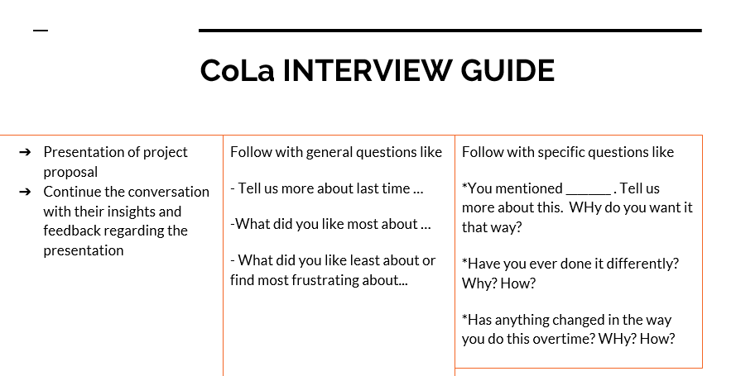

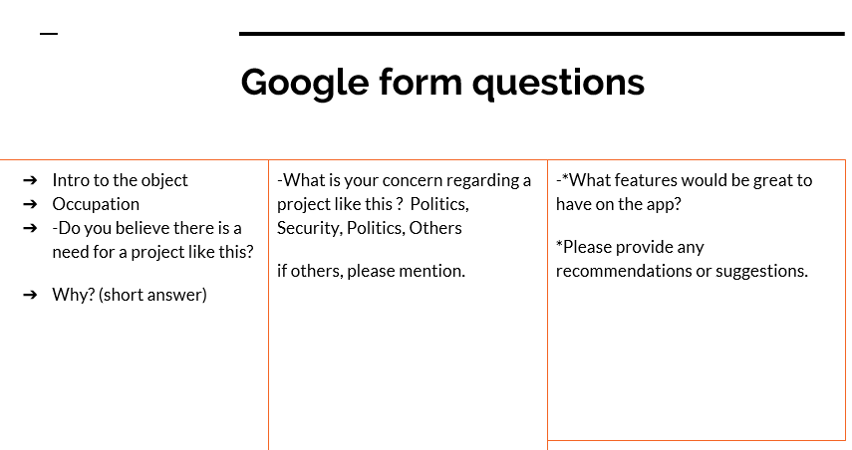

### **3.1.2 Functional requirement**

* The application will contain current map from ZMI data.
* The application will contain master plan of Zanzibar.
* The application will load according to user current location.
* The authorized personal will be capable of uploading the layer to the application from server side.
* Administrator can approval the changes could be made by authorized user of the system.

### **3.1.3 Non – functional requirement**

* The application will easy to use and user friendly.
* The application will only display only data the allowed to be shown (Only legal data).
* The application will be accessible all the time through internet.
* The platform will be faster and responsive.
* The application will need minimal memory to work and operate.
* In term of scalability the application will be increasing if needed.

## **3.2 Requirement Structuring**

As mentioned before that we will be using the object oriented approach. There in the process model, we will be using the use case diagram for process modeling. And class and entity relationship diagram for data modeling.

### **3.2.1 Process Model**

#### 3.2.1.1 Current System Use Case Diagram

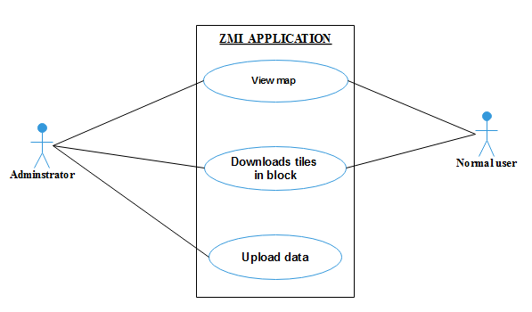

Figure 2 : Current System Use Case Diagram

#### 3.2.1.2 Proposed System Use Case Diagram

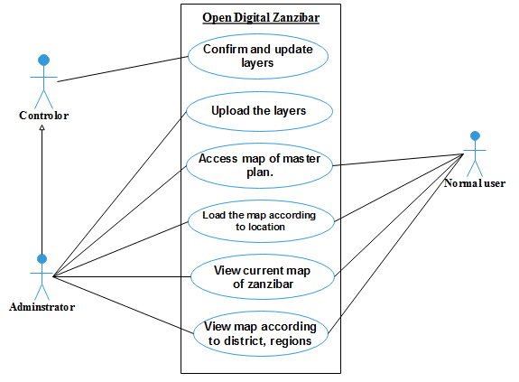

Figure 3 : Proposed System Use Case Diagram

### **3.2.2 Data Modeling**

#### **3.2.2.1 Class Diagram**

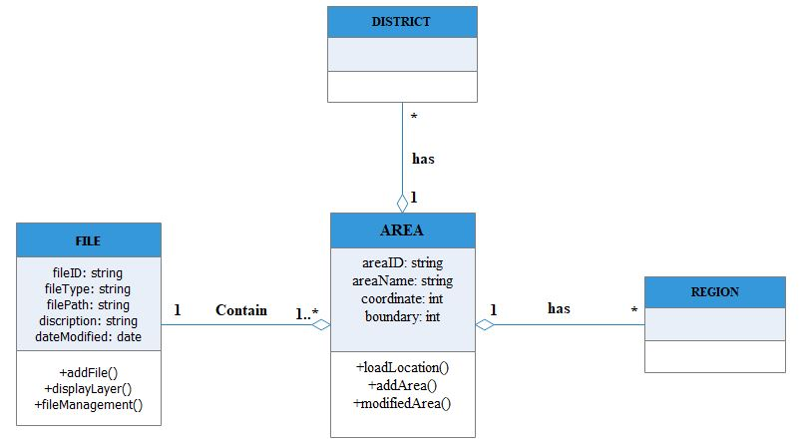

Figure 4: Class Diagram

#### **3.2.2.2 Entity relationship diagram**

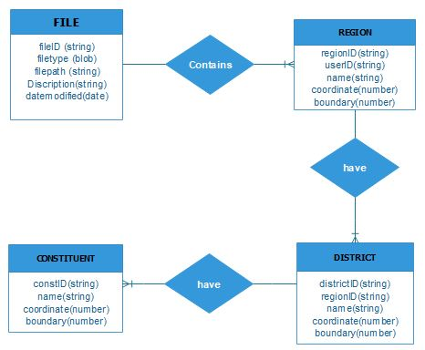

Figure 5 : Entity Relationship Diagram (ERD)

# **4 CHAPTER 4: System Design**

## 4.1 Architectural Design

Area Data

ZMI (Zanzibar Mapping Iniative) Data

GPS Location

Open Digital Zanzibar

Map

Contains

Map Coordinates

Master plan Map

## 4.2 Database Design

### 4.2.1 Relational Model

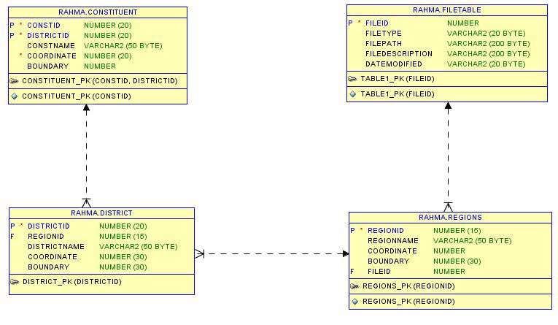

### 4.2.2 Data Description

#### CONSTITUENT

CREATE TABLE **CONSTITUENT**

(CONSTID NUMBER NOT NULL, DISTRICTID NUMBER, CONSTNAME VARCHAR2(50 BYTE), COORDINATE NUMBER, BOUNDARY NUMBER, CONSTRAINT CONSTITUENT_PK PRIMARY KEY (CONSTID));

ALTER TABLE CONSTITUENT ADD CONSTRAINT HAVE FOREIGN KEY

(DISTRICTID) REFERENCES DISTRICT(DISTRICTID);

#### DISTRICT

CREATE TABLE **DISTRICT**

(DISTRICTID NUMBER (20, 0) NOT NULL, REGIONID NUMBER (20, 0), DISTRICTNAME VARCHAR2(50 BYTE), COORDINATE NUMBER (30, 0), BOUNDARY NUMBER (30, 0) CONSTRAINT DISTRICT_PK PRIMARY KEY (DISTRICTID));

ALTER TABLE DISTRICT ADD CONSTRAINT HAVE FOREIGN KEY

(REGIONID) REFERENCES REGIONS (REGIONID);

#### REGIONS

CREATE TABLE **REGIONS**

(REGIONID NUMBER (15, 0) NOT NULL, REGIONNAME VARCHAR2(50 BYTE), COORDINATE NUMBER, BOUNDARY NUMBER (30, 0), FILEID NUMBER, CONSTRAINT REGIONS_PK PRIMARY KEY (REGIONID));

ALTER TABLE REGIONS ADD CONSTRAINT CONTAIN FOREIGN KEY

(FILEID) REFERENCES FILETABLE (FILEID);

#### FILETABLE

CREATE TABLE **FILETABLE**

(FILEID NUMBER NOT NULL, FILETYPE VARCHAR2 (20 BYTE), FILEPATH VARCHAR2(200 BYTE), FILEDESCRIPTION VARCHAR2(200 BYTE), DATEMODIFIED VARCHAR2(20 BYTE), CONSTRAINT FILETABLE_PK PRIMARY KEY (FILEID));

### 4.2.3 Data Dictionaries

**FILETABLE**

|  |  |  |  |  |
| --- | --- | --- | --- | --- |
| FILEID | FILETYPE | FILEPATH | FILEDESCRIPTION | DATEMODIFIED |

|  |  |  |  |  |  |
| --- | --- | --- | --- | --- | --- |
| **FILETABLE** | | **DATA SIZE** | **DATATYPE** | **CONSTRAINT** | **EXAMPLE** |
| **PK** | fileid | integer value in incremental | int | NOT NULL | 1,2,3 |
|  | filetype | varchar2 (20 byte) | varchar | NOT NULL | .sh, .tiff |
|  | filepath | varchar2 (200 byte) | varchar | NOT NULL | ../odz/map/data.tiff |
|  | filedescription | varchar2 (200 byte) | varchar | NULL | This is current map of zanzibar |
|  | datemodified | Date | date | NULL | 12.01.2018 |

|  |  |  |  |  |
| --- | --- | --- | --- | --- |
| REGIONID | REGIONNAME | COORDINATE | BOUNDARY | FILEID |

**REGIONS**

|  |  |  |  |  |  |
| --- | --- | --- | --- | --- | --- |
| **REGIONS** | | **DATA SIZE** | **DATATYPE** | **CONSTRAINT** | **EXAMPLE** |
| **PK** | regionid | integer value in incremental | int | NOT NULL | 1,2,3.. |
|  | regionname | varchar2 (50 byte) | varchar | NOT NULL | k.zanzibar, mjini maghrib |
|  | coordinate | Integar (20) | int | NOT NULL | 565675’E, 06535436’W |
|  | boundary | Integar (20) | int | NOT NULL | 565675’E, 06535436’W,565675’E, 06535436’W,565675’E, 06535436’W |
|  | fileid | Integer (11) | int | NOT NULL | 1,2,3.. |

|  |  |  |  |  |  |
| --- | --- | --- | --- | --- | --- |
| **DISTRICTS** | | **DATA SIZE** | **DATATYPE** | **CONSTRAINT** | **EXAMPLE** |
| **PK** | districtid | integer value in incremental | int | NOT NULL | 1,2,3.. |
|  | districtname | varchar2 (50 byte) | varchar | NOT NULL | Kwerekwe, mjini |
|  | coordinate | Integar (20) | int | NOT NULL | 565675’E, 06535436’W |
|  | boundary | Integar (20) | int | NOT NULL | 565675’E, 06535436’W,565675’E, 06535436’W,565675’E, 06535436’W |
|  | regionid | Integer (11) | int | NOT NULL | 1,2,3.. |

**DISTRICT**

|  |  |  |  |  |
| --- | --- | --- | --- | --- |
| DISTRICTID | DISTRICTNAME | COORDINATE | BOUNDARY | REGIONID |

**CONSTITUENT**

|  |  |  |  |  |  |
| --- | --- | --- | --- | --- | --- |
| **CONSTITUENT** | | **DATA SIZE** | **DATATYPE** | **CONSTRAINT** | **EXAMPLE** |
| **PK** | Costid | integer value in incremental | int | NOT NULL | 1,2,3.. |
|  | constname | varchar2 (50 byte) | varchar | NOT NULL | kikwajuni, Nyerere |
|  | coordinate | Integar (20) | int | NOT NULL | 565675’E, 06535436’W |
|  | boundary | Integar (20) | Int | NOT NULL | 565675’E, 06535436’W,565675’E, 06535436’W,565675’E, 06535436’W |
|  | districtid | Integer (11) | Int | NOT NULL | 1,2,3.. |

|  |  |  |  |  |
| --- | --- | --- | --- | --- |
| CONSTID | CONSTNAME | COORDINATE | BOUNDARY | DISTRICTID |

## 4.3 User Interface Design

### 4.3.1 Forms and reports

#### 4.3.1.1 Forms

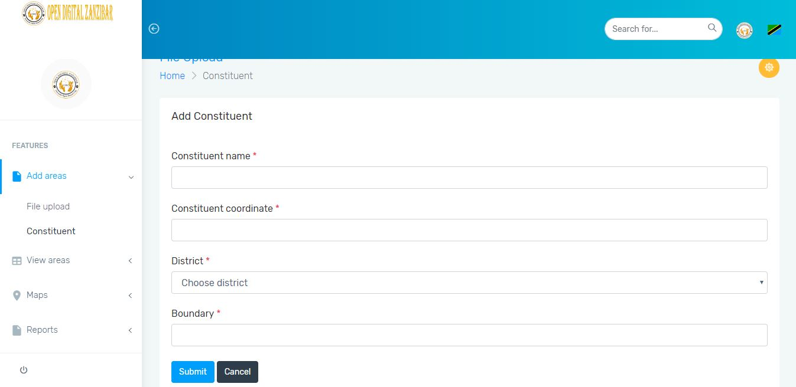

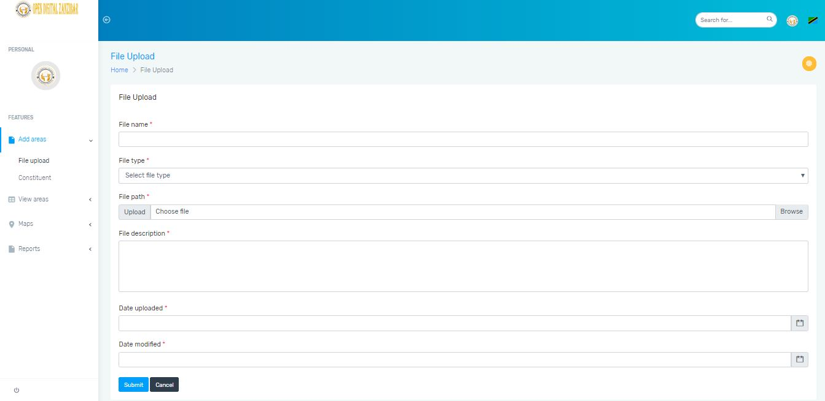

#### 4.3.1.2 Report

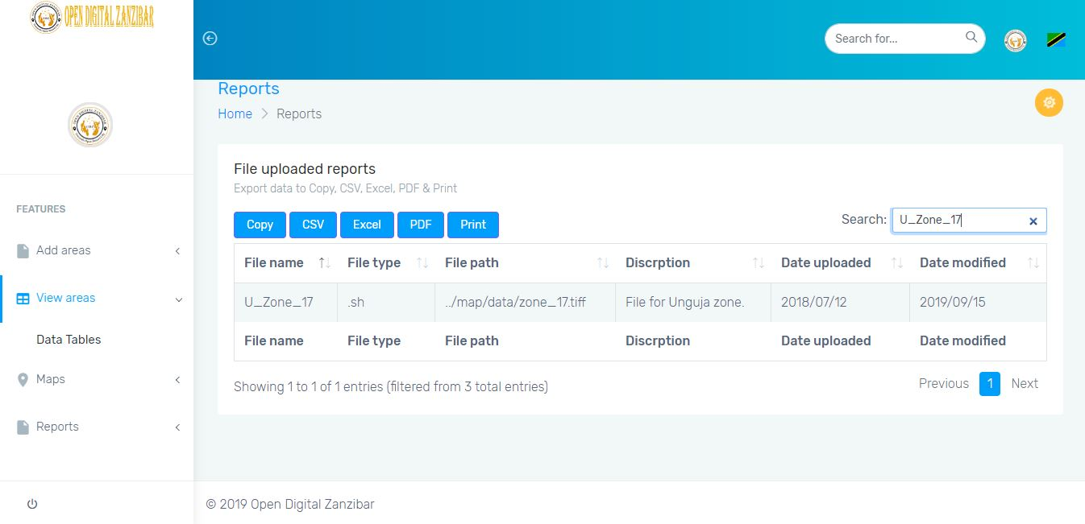

### 

### 4.3.2 Interface design sample

#### 4.3.2.1 Mobile Device Interface (Client side)

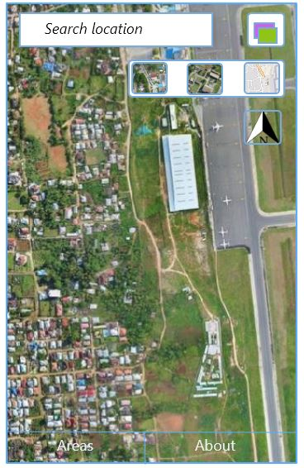

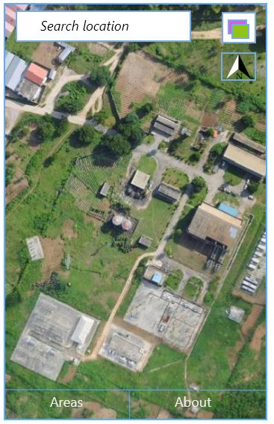

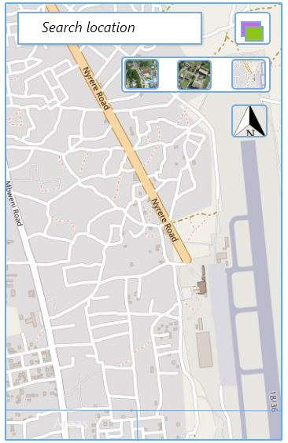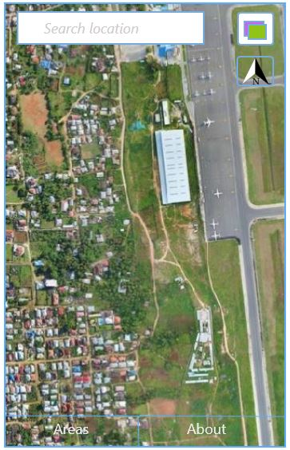

#### 4.3.2.1 Web Interface (Server side)

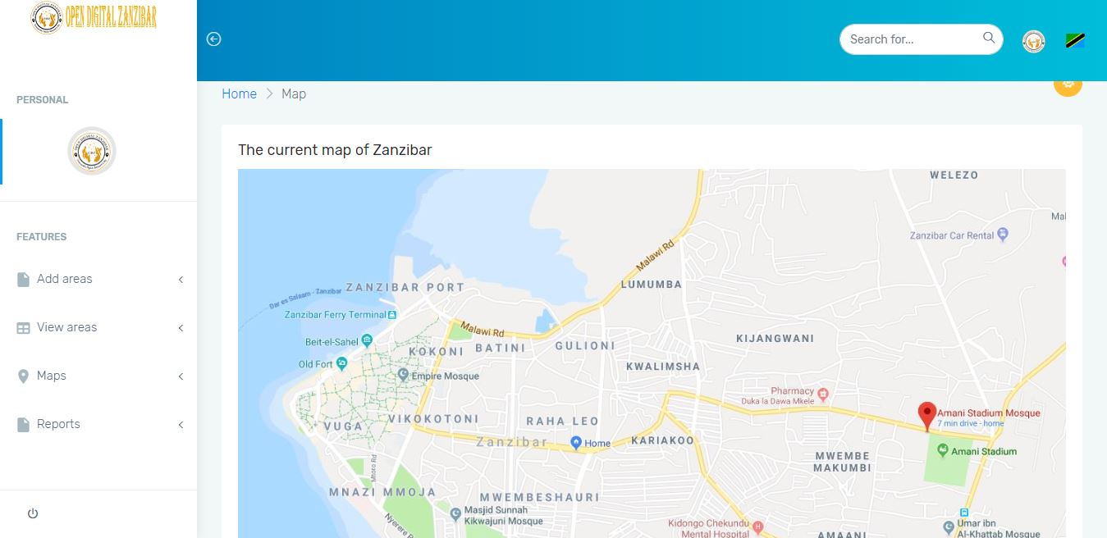

# USEFUL LINKS

* Google form survey :

<https://docs.google.com/forms/d/e/1FAIpQLSdMYdcLMLQtRX5WNVHOMD4tmHP-Q3V9zj2suTT4wqWnmKv-Rg/viewform?vc=0&c=0&w=1&usp=mail_form_link>

* Github

<https://github.com/amhafidh/OpenDigitalZanzibar>

# **REFERENCES**

# Mathers ,Smather (2017, June 12) ZMI - Zanzibar Mapping Initiative Level 1 . Retrieved from

<https://smathermather.com/2017/06/12/zmi-zanzibar-mapping-initiative-level-1/>

Google map. Retrieved from

<https://en.m.wikipedia.org/wiki/Google_Maps>

OpenStreetMap . Retrieved from <https://en.m.wikipedia.org/wiki/OpenStreetMap>

Opencities Africa [https://opencitiesproject.or’g/](https://opencitiesproject.or'g/)

Zanzibar Maapping Iniative website <http://www.zanzibarmapping.com/>

Zanzibar Maapping Iniative video <https://www.youtube.com/watch?v=qVEdhSodIeE&t=37s>

Kapahi, Mayink . (20017, March 14). 5 Benefits of a 3-Tier Architecture. Retrieved from [**https://www.izenda.com/blog/5-benefits-3-tier-architecture/**](https://www.izenda.com/blog/5-benefits-3-tier-architecture/)